# Overview:

We can use Github.com to host our website files for this course and for others (like IDN531). This guide will instruct the following:

1. Create a Github.com account
2. Create a repository
3. Download and set up GitHub Desktop
4. Login to your repository & add content
5. Push to Github and Preview

## Step 1: Create a Github.com account

1. Using a browser, navigate to <https://github.com>
2. Click **Sign Up** and follow the prompts to create a new account.
3. Take note of your username, we will need it for the next step

## Step 2: Create a repository

1. In the top right corner of the page, click the **+** button and the click “**New Repository”**
2. In the **Repository name** input, you must enter your “**accountname.github.io**”
   1. If your GitHub username is MickeyMouse, then the Repository name would be mickeymouse.github.io
3. 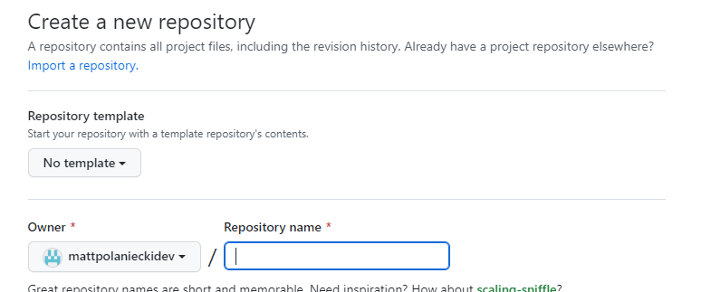Scroll to the bottom of the page and click “**Create Repository**”

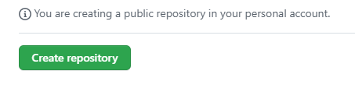

## Step 3: Download and setup GitHub Desktop

1. Using your browser, navigate to <https://desktop.github.com>
2. Click **Download**, then complete the installation.
3. Launch **GitHub Desktop**
4. You will be prompted to sign in, or click **File, Options, Accounts, Sign In**
5. 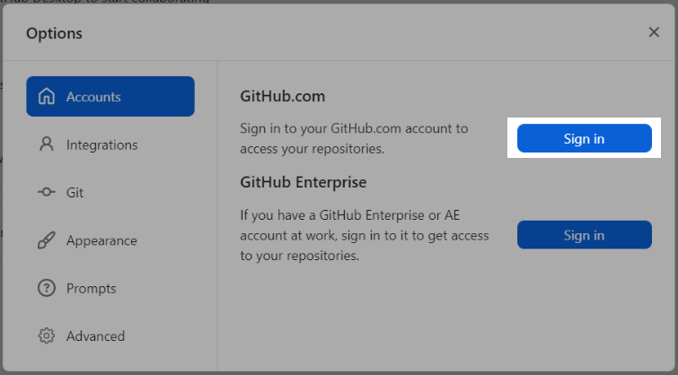Continue through the prompts and it will launch a browser asking you to sign in
6. **Sign in** using your GitHub user account and password

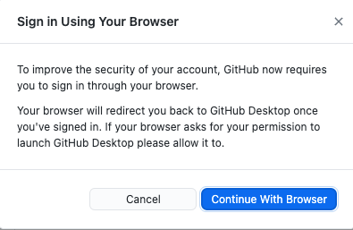

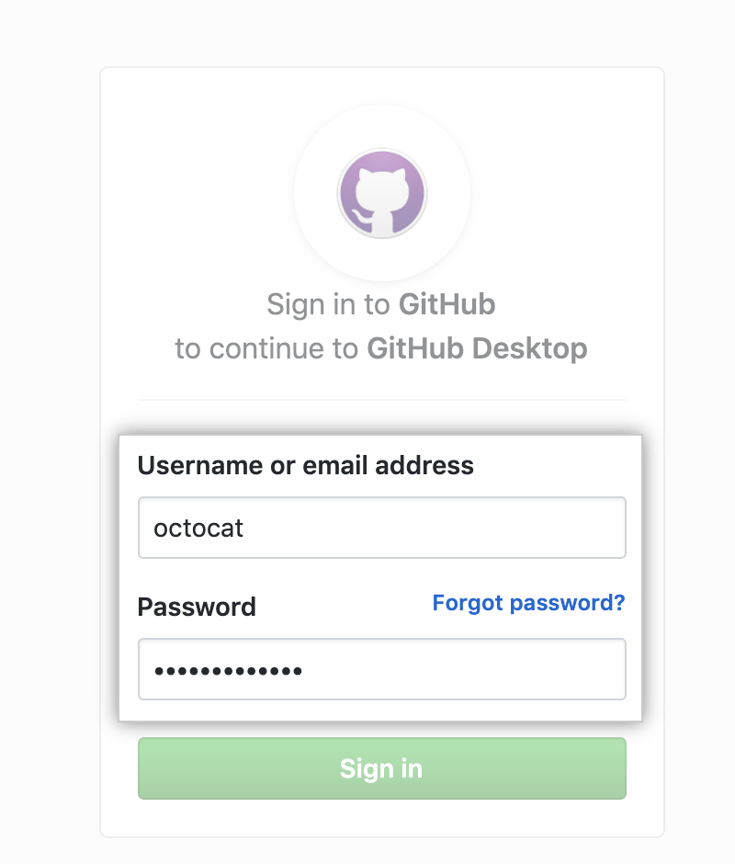

## Step 4: Login to Repository & Add content

1. In GitHub Desktop, click File, Clone repository
2. Select your previously created repository (accountname.github.io)
3. Click **“Clone”**
4. Click “Show in Explorer” (PC) or “Show in Finder” (Mac)
5. An empty folder will appear
6. **Copy and paste the exported eLearning/SCORM folder into this folder.**

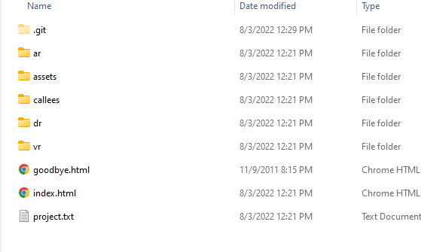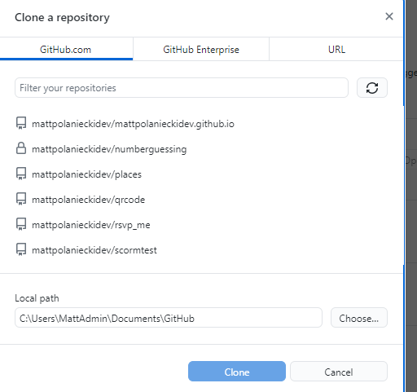

## Push files to GitHub and Preview

1. 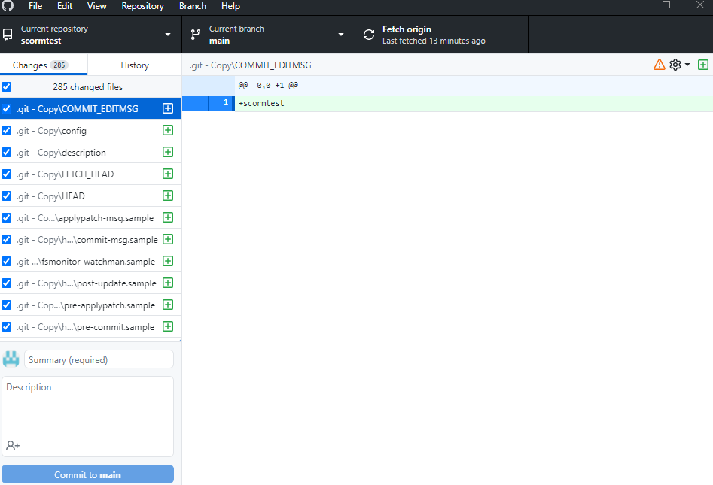Return to the previously opened **GitHub Desktop**
   1. You will see many files added in the Changes column.
2. Click the “**Summary**” box at the bottom, and add any text, like “**Version 1**”.
3. Click “**Commit to main**”
4. Then click “**Push origin**”
5. The files will sync to the web. Wait a few minutes for the sync to be completed.
6. **Open a browser** and access your URL at <https://youraccountname.github.io>/foldername
7. 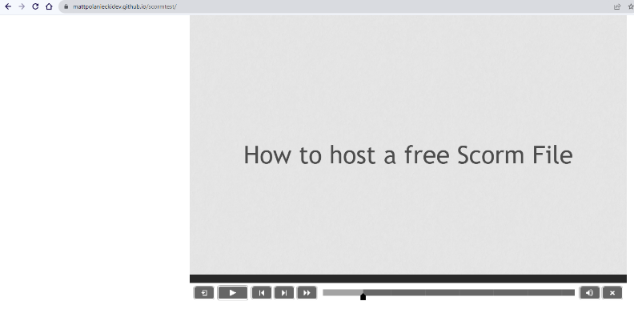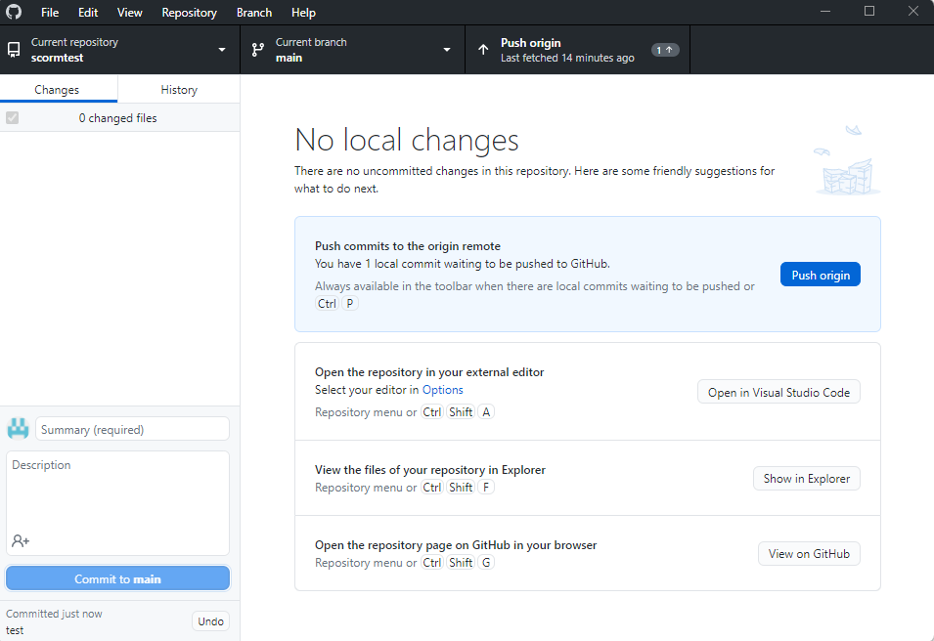The eLearning/scorm file will appear.